**COMPLETE END TO END PROJECT OF MATILLION INVOLVING AWS S3 & SNS, SNOWFLAKE, POWER BI AND GIT.**

# What is matillion?

Matillion ETL is a **cloud-native ETL solution** that simplifies the process of collecting, preparing, and loading data. It’s a drag and drop interface which helps build scalable data pipelines without the need for extensive coding.

DID YOU KNOW: Matillion named a **Challenger** in the **2023 Gartner®Magic Quadrant™ report** for Data Integration Tools.

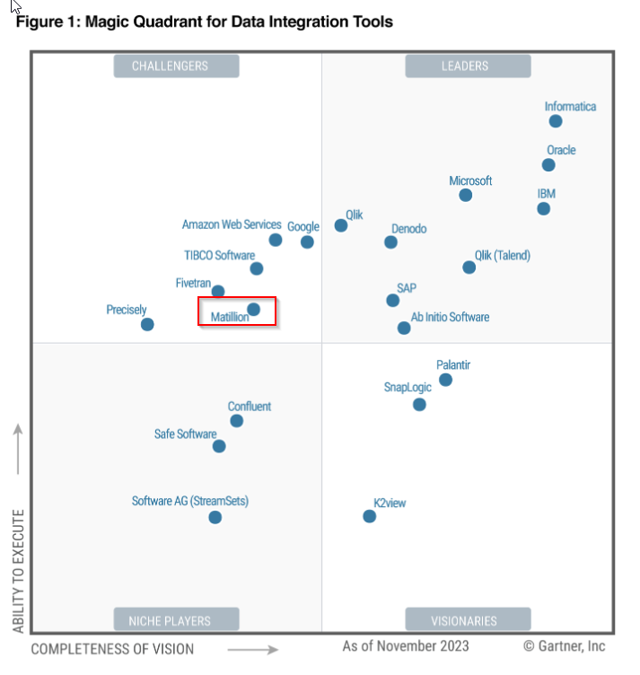

# What is AWS S3?

Simply say, it’s a cloud based storage service.

# What is snowflake?

Like matillion, snowflake is built for the cloud. It’s a cloud-hosted, relational database that enables you to build data warehouses on demand

# What is always- on tables?

The data in table is available always.

Why is it a best practice?

* + Reload can take a long time for huge tables
  + When reloading, only partial data will be available to integrated tools, hence incorrect results

# Architecture of today’s project:

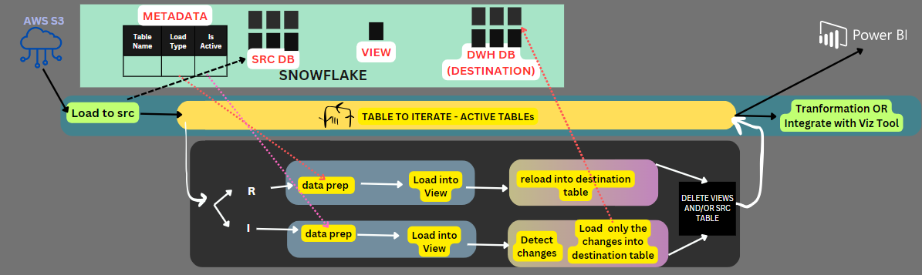

# Prep:

* + - An active AWS and Snowflake account
    - Create an matillion account (ETL setup) – refer doc: Steps To Configure Matillion.docx

# Gist of Working:

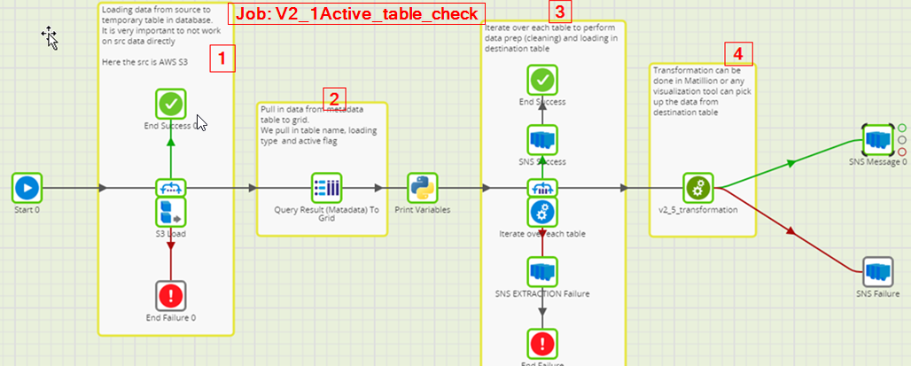

### Load the data from S3 to Snowflake src table [S3 LOAD]

### Pull in info from metadata table into the GRID Variable [QUERY RESULT TO GRID]

### Iterate all the next steps for each table [FIXED ITEARATOR + ORCHESTRATION JOB] + Notification [SNS]



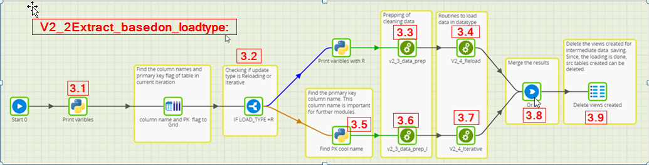

#### Retrieve the column name and primary key of the table [table metadata to grid]

#### Check if the table needs to be iterated or reloaded [IF component]

#### For R: Prepare /clean the data [Run transformation component]

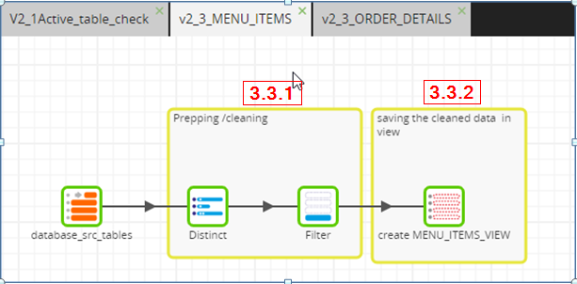

#### Cleaning [DISTINCT + FILTER NULLS]

#### Save it in a view [CREATE VIEW]

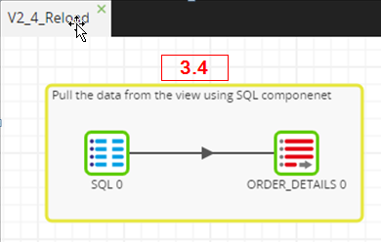

#### For R : Load the data from the VIEW into the destination database [RUN transformation component]

#### For I: Identify the name of the primary key using the flag [Python script]

#### For I: Prepare /clean the data [Run transformation component]

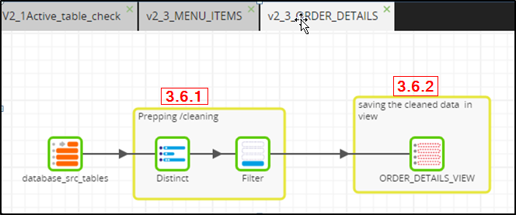

#### Cleaning [DISTINCT + FILTER NULLS]

#### Save it in a view [CREATE VIEW]

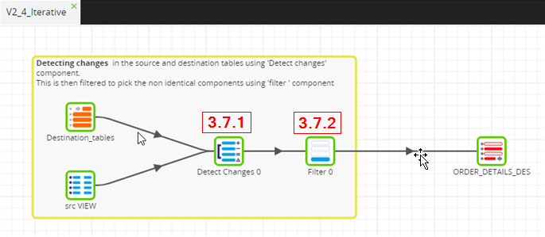

#### For I: Load the data from the VIEW into the destination database [RUN transformation component]

#### Detect changes [Detect changes]

#### Filter rows that need to be Upserted [filter]

#### Irrespective of R or I , the pipeline needs to be merged [OR]

#### Since the cleaning and loading is completed, Unnecessary data/ structure is removed [SQL SCRIPT]

### You can perform transformations to retrieve value /KPI OR use the data as input to any visualization tool. [RUN transformation component]

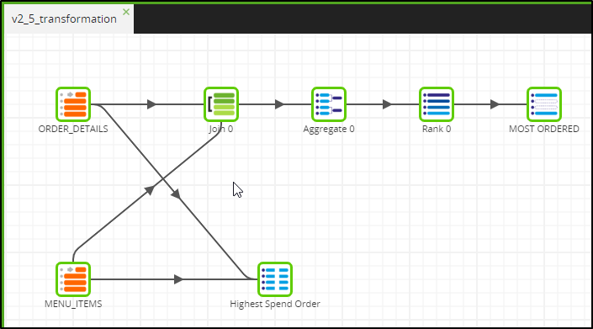

# DETAILED:



### Create an orchestration job V2_1Active_table_check

### Prep:

* + - First Create following Job Variables:

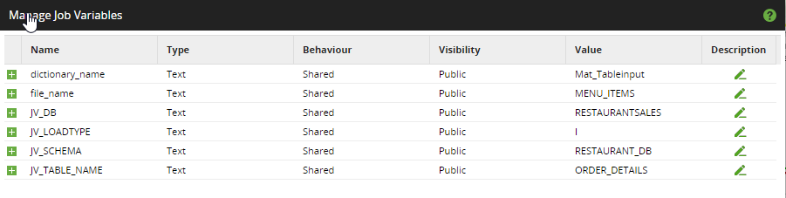

Text Mode:

dictionary_name Text Shared Public Mat_Tableinput

file_name Text Shared Public MENU_ITEMS

JV_DB Text Shared Public RESTAURANTSALES

JV_LOADTYPE Text Shared Public I

JV_SCHEMA Text Shared Public RESTAURANT_DB

JV_TABLE_NAME Text Shared Public ORDER_DETAILS

* + - Create Grid variables:

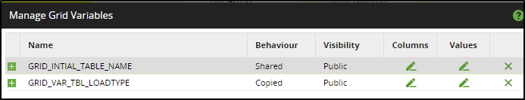

GRID_VAR_TBL_LOADTYPE

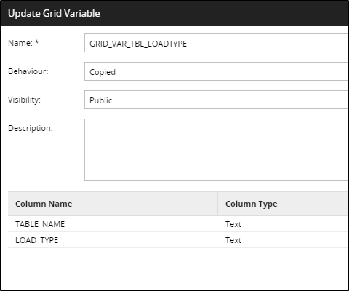 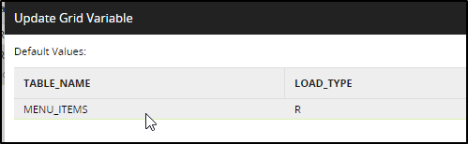

TEXT Mode:

TABLE_NAME Text

LOAD_TYPE Text

* Configuring SNS
  + AWS SNS > Create SNS topic > Configure subscription

### Load the data from S3 to Snowflake src table [S3 LOAD + File Iterator]

* + **properties of S3 load:**

|  |  |
| --- | --- |
| Name | S3 Load |
| Stage | Matillion_Stage |
| Pattern | ${file_name}.csv |
| Warehouse | MATILLION_PRG |
| Database | ${JV_DB} |
| Schema | ${JV_SCHEMA} |
| Target Table | ${file_name.replace(/"/g,'')} |

NOTE: Please set ‘Force Load ‘ to True

**Properties of Fixed Iterator:**

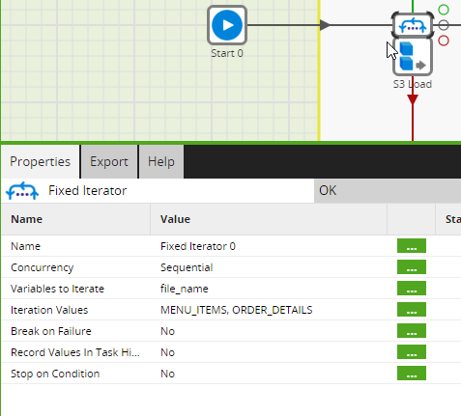

|  |  |  |
| --- | --- | --- |
| Variables to Iterate | file_name |  |
| Iteration Values | MENU_ITEMS, ORDER_DETAILS |  | |



### Pull in info from metadata table into the GRID Variable [QUERY RESULT TO GRID]

Properties:

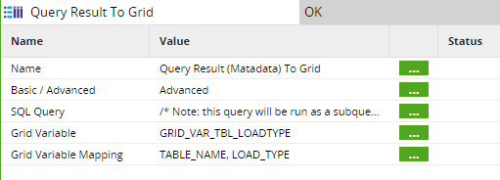

**SQL QUERY :**

SELECT

UPPER(TABLE_NAME) TABLE_NAME,UPPER(LOAD_TYPE) LOAD_TYPE,IS_ACTIVE

FROM

RESTAURANTSALES.RESTAURANT_METADATA.TABLE_LOAD_METADATA

WHERE IS_ACTIVE =1

Python script – just to display variables (Also helps in displaying message in the logs

**Script:**

print (context.getGridVariable('GRID_VAR_TBL_LOADTYPE'))

print(JV_TABLE_NAME)

print (JV_LOADTYPE)

Logs:

### Iterate all the next steps for each table [FIXED ITEARATOR + ORCHESTRATION JOB] + Notification [SNS]



Points to ponder: Why we have added iterator here? Since we are iterating to another transformation job, why don’t we do it in the same job?

**Run Orchestration: V2_2Extract_basedon_loadtype2**

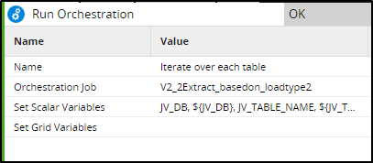

First configure variables:

Job Variables:

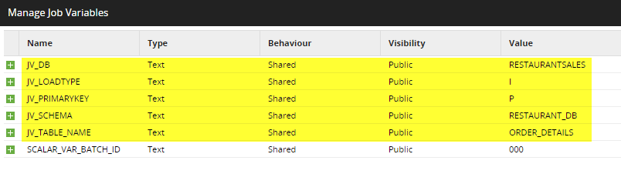

Text mode:

JV_DB Text Shared Public RESTAURANTSALES

JV_LOADTYPE Text Shared Public I

JV_PRIMARYKEY Text Shared Public P

JV_SCHEMA Text Shared Public RESTAURANT_DB

JV_TABLE_NAME Text Shared Public ORDER_DETAILS

—--------------------------------------------------------------------------------------------------------------------------------------------------

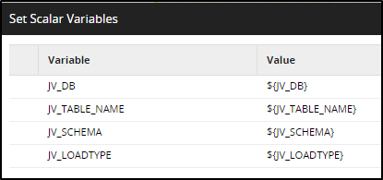

Text Mode:

JV_DB ${JV_DB}

JV_TABLE_NAME ${JV_TABLE_NAME}

JV_SCHEMA ${JV_SCHEMA}

JV_LOADTYPE ${JV_LOADTYPE}

Points to ponder? What is set scalar variables?

**Iterator:**

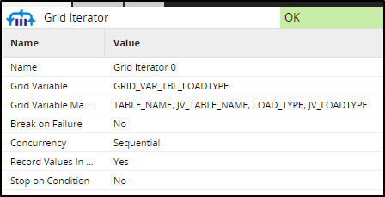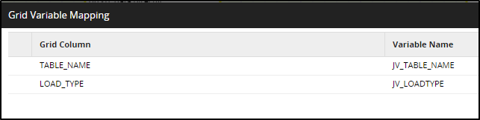

Text Mode:

TABLE_NAME JV_TABLE_NAME

LOAD_TYPE JV_LOADTYPE

SNS Message:

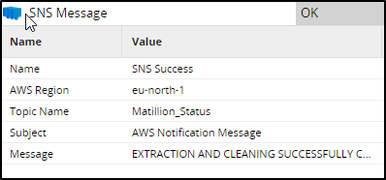

|  |  |
| --- | --- |
| Message for success:  EXTRACTION AND CLEANING SUCCESSFULLY COMPLETED  JOB ID:${job_id}  JOB NAME: ${job_name}  MESSAGE:${component_message} | Message for failure:  Needs attention!!! Job failed :-(  JOB ID:${job_id}  JOB NAME: ${job_name}  MESSAGE:${component_message}  DETAILED ERROR:${detailed_error} |

End success and end failure:



Create another Orchestration job: **V2_2Extract_basedon_loadtype2**

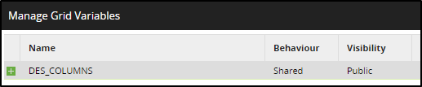

|  |  |
| --- | --- |
| Text Mode:  COl_name Text  Primary_key Text | Text Mode:  ORDER_DETAILS_ID Yes  ORDER_ID No  ORDER_DATE No  ORDER_TIME No |

#### Retrieve the column name and primary key of the table [table metadata to grid]

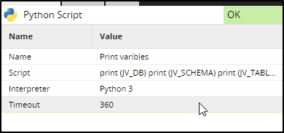

print (JV_DB)

print (JV_SCHEMA)

print (JV_TABLE_NAME)

Table Metadata To Grid:

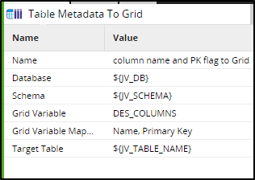

#### Check if the table needs to be iterated or reloaded [IF component]

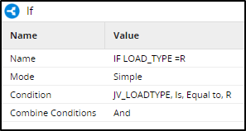

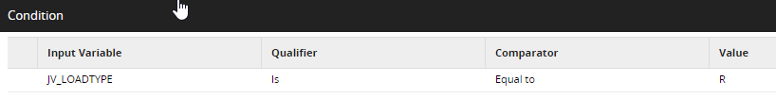

#### For R: Prepare /clean the data [Run transformation component]



**Python component:**

print (JV_DB)

print (JV_SCHEMA)

print (JV_TABLE_NAME)

print(context.getGridVariable('DES_COLUMNS'))

—------------------------------------------------------------------------------------

Create a Transformation job – V2_3_MENU_ITEMS



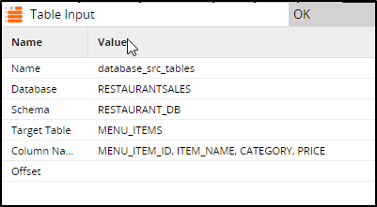

#### Cleaning [DISTINCT + FILTER NULLS]

Distinct:

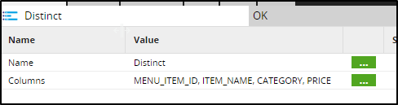

Filter:

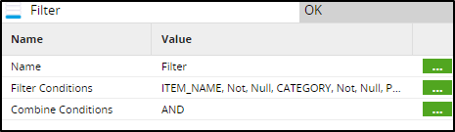

Filter Condition (Text Mode)

ITEM_NAME Not Null

CATEGORY Not Null

PRICE Not Null

#### Save it in a view [CREATE VIEW]

Create view:

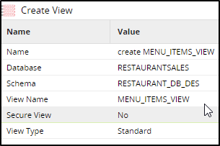

**Create a Transformation job – V2_4_Reload**



* Configure job variables:

JV_DB Text Shared Public RESTAURANTSALES

JV_SCHEMA Text Shared Public RESTAURANT_DB

JV_TABLE_NAME Text Shared Public MENU_ITEMS

* configure grid variable

DES_COLUMNS grid variables

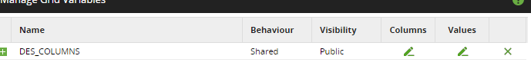

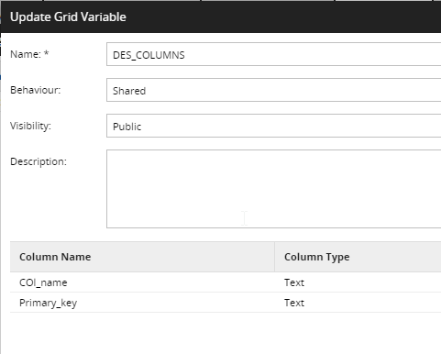

TEST mode:

COl_name Text

Primary_key Text

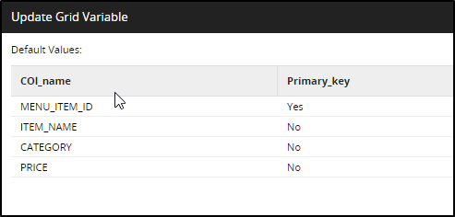

TExt mode:

MENU_ITEM_ID Yes

ITEM_NAME No

CATEGORY No

PRICE No

* SQL:

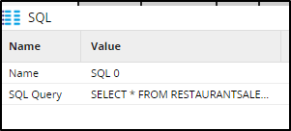

SELECT * FROM RESTAURANTSALES.RESTAURANT_DB_DES.${JV_TABLE_NAME}_VIEW

Table output: - write an input data flow out to an existing output table.

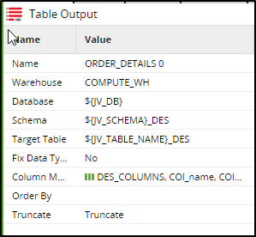

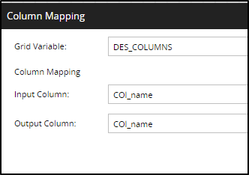

—-----------------------------------------------------------------------------------

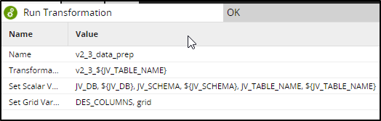

v2_3_${JV_TABLE_NAME}

Text Mode:

JV_DB ${JV_DB}

JV_SCHEMA ${JV_SCHEMA}

JV_TABLE_NAME ${JV_TABLE_NAME}

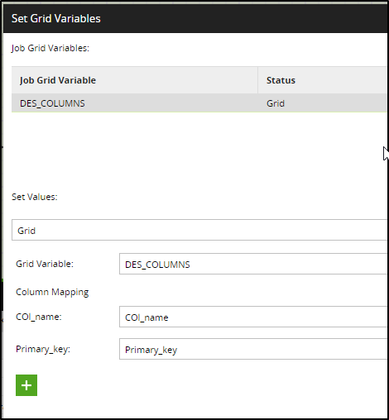

#### For R : Load the data from the VIEW into the destination database [RUN transformation component]

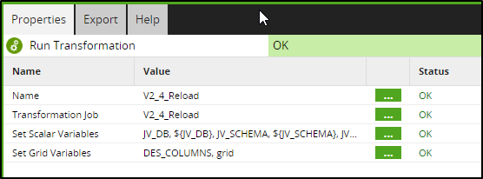

set scalar variable:

JV_DB ${JV_DB}

JV_SCHEMA ${JV_SCHEMA}

JV_TABLE_NAME ${JV_TABLE_NAME}

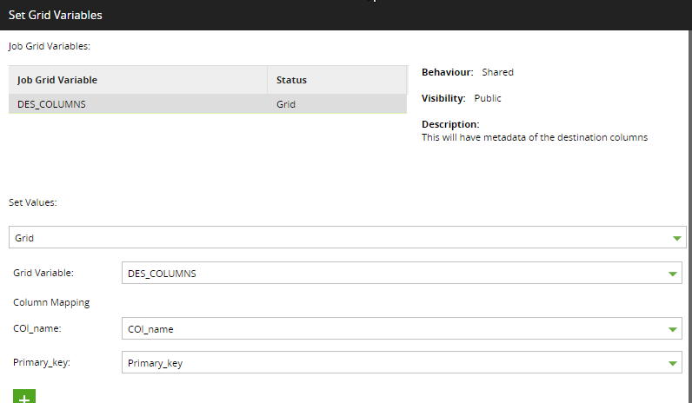



#### For I: Identify the name of the primary key using the flag [Python script]

Python script:

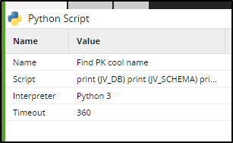

for i in context.getGridVariable('DES_COLUMNS'):

if i[1]=='Yes':

context.updateVariable('JV_PRIMARYKEY', i[0])

print(JV_PRIMARYKEY)

#### For I: Prepare /clean the data [Run transformation component]

Run transformation component:

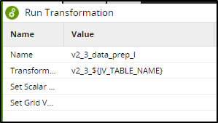

Create a Transformation job – V2_3_ORDER_DETAILS



adding variables:

text mode:

JV_DB Text Shared Public RESTAURANTSALES

JV_SCHEMA Text Shared Public RESTAURANT_DB

JV_TABLE_NAME Text Shared Public ORDER_DETAILS

Grid variables:

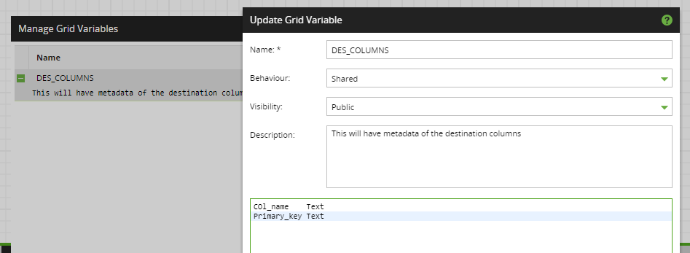

COl_name Text

Primary_key Text

Values:

ORDER_DETAILS_ID Yes

ORDER_ID No

ORDER_DATE No

ORDER_TIME No

ITEM_ID No

Table input:

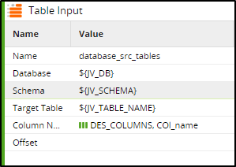

#### Cleaning [DISTINCT + FILTER NULLS]

Distinct

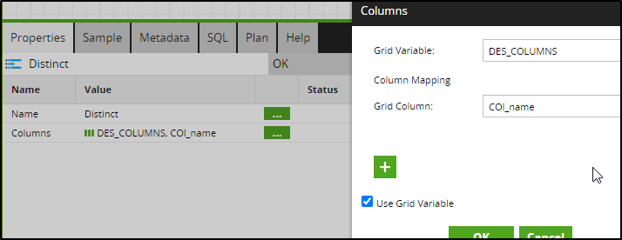

Filter

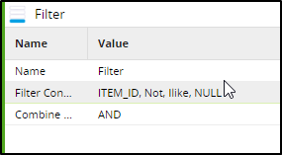

#### Save it in a view [CREATE VIEW]

View

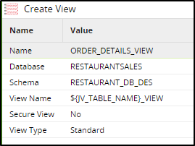



#### For I: Load the data from the VIEW into the destination database [RUN transformation component]

Create a Transformation job – V2_4_Iterative

Copy the Grid variables and Job variables

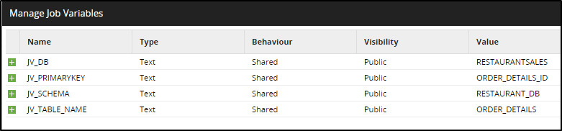

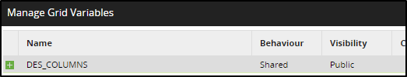

Run transformation component:

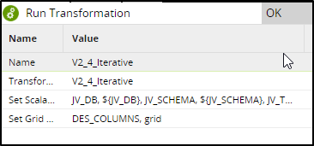



#### Detect changes [Detect changes]

Table input:

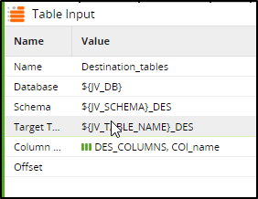

**SQL query**

SELECT * FROM RESTAURANTSALES.RESTAURANT_DB_DES.${JV_TABLE_NAME}_VIEW

**Detect changes**

Don’t worry about the errors at this point. It’s because these don’t have columns its searching for. Once the iteration start, the right columns will come in.

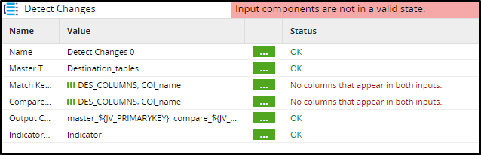

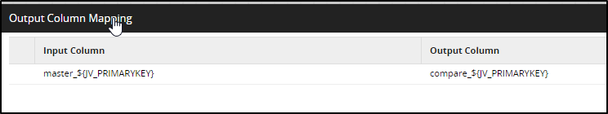

Test mode:

master_${JV_PRIMARYKEY} compare_${JV_PRIMARYKEY}

#### Filter rows that need to be Upserted [filter]

**Filter**

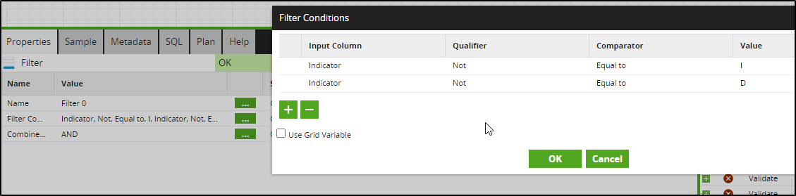

Text mode:

Indicator Not Equal to I

Indicator Not Equal to D

**Upsert**

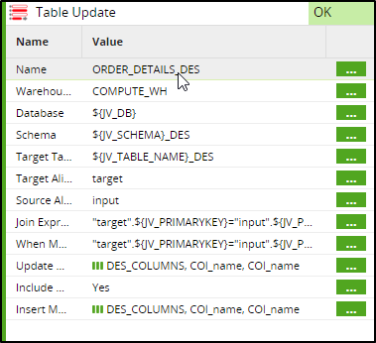

JOIN expression: "target".${JV_PRIMARYKEY}="input".${JV_PRIMARYKEY}

WHEN marched: "target".${JV_PRIMARYKEY}="input".${JV_PRIMARYKEY} Update

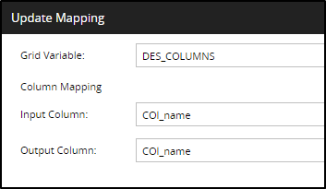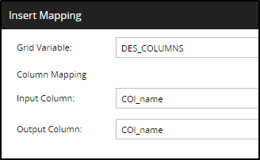



#### Irrespective of R or I , the pipeline needs to be merged [OR]

OR

#### Since the cleaning and loading is completed, Unnecessary data/ structure is removed [SQL SCRIPT]

SQL script

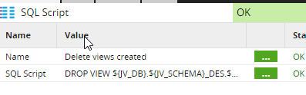

Script:

DROP VIEW ${JV_DB}.${JV_SCHEMA}_DES.${JV_TABLE_NAME}_VIEW;

-- TRUNCATE TABLE ${JV_DB}.${JV_SCHEMA}.${JV_TABLE_NAME}

#### You can perform transformations to retrieve value /KPI OR use the data as input to any visualization tool. [RUN transformation component]

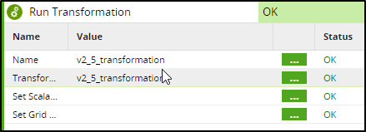

Create Transformation Job – V2_5_Tranformation

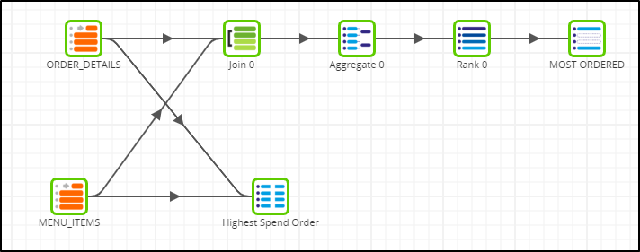

ORDER DETAILS/Menu Items:  
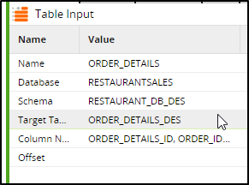

JOIN:

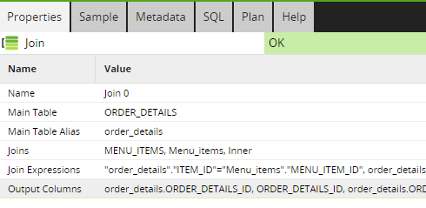

JOINS: "order_details"."ITEM_ID"="Menu_items"."MENU_ITEM_ID"

JOIN Expression: "order_details"."ITEM_ID"="Menu_items"."MENU_ITEM_ID"

OUTPUT COLUMS:

order_details.ORDER_DETAILS_ID ORDER_DETAILS_ID

order_details.ORDER_ID ORDER_ID

order_details.ORDER_DATE ORDER_DATE

order_details.ORDER_TIME ORDER_TIME

order_details.ITEM_ID ITEM_ID

Menu_items.MENU_ITEM_ID MENU_ITEM_ID

Menu_items.ITEM_NAME MENU_ITEM_NAME

Menu_items.CATEGORY MENU_CATEGORY

Menu_items.PRICE MENU_PRICE

AGGREGATE:

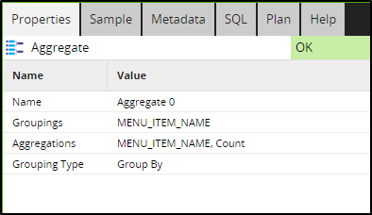

RANK:



FIRST/LAST:

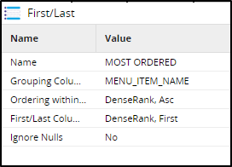

SQL:



SELECT OD.order_ID, SUM(PRICE) ORDER_SPEND FROM RESTAURANTSALES.RESTAURANT_DB_DES.ORDER_DETAILS_DES OD

INNER JOIN RESTAURANTSALES.RESTAURANT_DB_DES.MENU_ITEMS_DES MI

ON OD.ITEM_ID=MI.MENU_ITEM_ID

GROUP BY order_ID

ORDER BY 2 DESC LIMIT 1

SNS Message: Same as first SNS

**Input to Viz tool:**

You could use this data you stored in the destination database (in snowflake) as input to any visualization tool.

Here, we will just integrate with power BI and if time permits we can change the data src to new destination database.

**GIT Integration:**

* + - * + [**https://docs.matillion.com/data-productivity-cloud/designer/docs/git-overview/**](https://docs.matillion.com/data-productivity-cloud/designer/docs/git-overview/)

**Scheduling:**

* + - * + **Project>schedules>add schedules>create new schedules**
        + **Uses Cron expressions**
        + [**https://docs.matillion.com/data-productivity-cloud/designer/docs/schedules/**](https://docs.matillion.com/data-productivity-cloud/designer/docs/schedules/)

References:

1. <https://www.matillion.com/blog/matillion-recognized-as-a-challenger-in-the-2023-gartner-magic-quadrant-for-data-integration-tools>
2. <https://docs.matillion.com/metl/docs/2037630/>
3. <https://www.matillion.com/blog/building-data-pipelines-always-on-tables-with-matillion-etl>
4. <https://www.matillion.com/blog/what-is-etl-the-ultimate-guide>
5. <https://docs.matillion.com/metl/docs/2917841/>
6. <https://docs.matillion.com/metl/docs/2943425/#contact-support>